**History of Twitter Reliability**

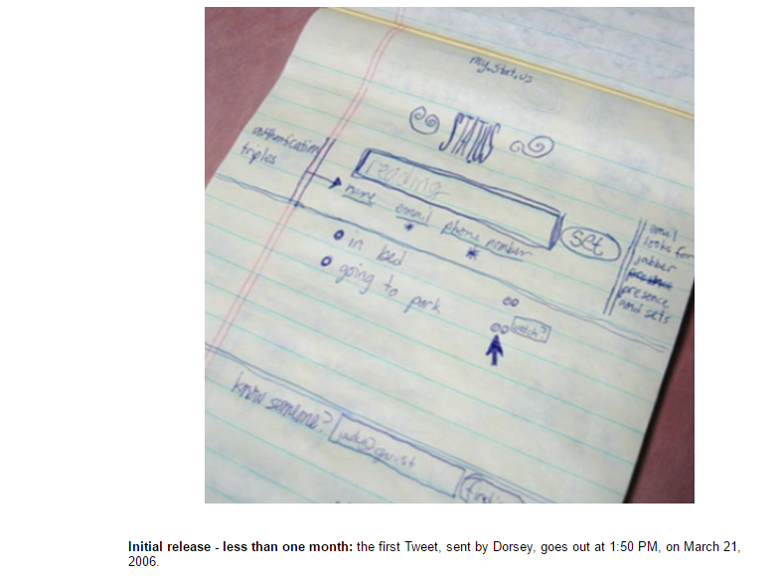Twitter is an online social media platform where every user can build some reliable opinions. This was created in March 2006 by Jack Dorsey, Noah Glass, Biz Stone and Evan Williams. [14]  They first created a prototype to simulate their idea which indicates a good feature for creating a good product.

Figure 1.0:- First Tweet

Figure 1.0 represents the ideation of first Twitter prototype that was used as an internal service for Odeo employees. For using such a service to a company like Odeo there should be a hidden solid background of Twitter. This is initially named as “Twttr” during a period of 2005 to 2006 as in the following image. [42]



Figure 1.1:- Twttr 2005-2006 prototype

Twttr is founded on February in 2006 and launched as twttr.com to all the private accounts on March 2006 and this was available to public on July 2006. [44] Therefore we can assume that there was an experimental era for twitter reliability from March to July in that same year. In order to make available Twttr accounts to public definitely there should be high reliable features which everyone can trust. On October 2006, it was rebranded as Twitter.com. [46]



Figure 1.2:- Twitter 2006–2010

Some people expected Twitter to work with larger ecosystem. As an example in September of 2006, RSS feeds and permalinks of tweets indicated users’ familiarity in blogging [45] which can be inherited from experience in tweeting. So these facts prove that there’s something believable figure of Twitter from the very beginning of this innovation.

Twitter reached its first tipping point at SXSW conference in March of 2007 while increasing 20,000 daily messages to 60,000 daily messages. [44] Such a massive 40,000 enhancements for average number of daily messages shows how this was become popular among the users within a short time period. In April of 2007, Twitter got incorporatedas a standalone company [44] which is an example for another milestone of their reliable evolution. This was introduced a mobile site, blocking capability feature and @replies column on May in 2007[44]  to expand their functionalities in a smart way. In June of 2007, Dell joined Twitter to corporate for business requirements [44] where we can predict Twitter was a reliable media even from that period. Your friends on Twitter were defined as followers from July 2007 onwards. And their updates were receiving to you all the time. [44] This facility would be a better opportunity to measure the reliability of your followers’ tweets. From August of 2007 onwards user could search people based on criteria such as location, name and more which can be called as ‘Twitter profile search goes live’. [44]  Introduction of tracking Twitter alias #Hashtags was happened in September 2007 as a development of earlier tracking feature. [44]  Such inventions may led Twitter to appear in CSI on November in 2007 as a reliable source. Eventually it had 400,000 tweets posted per quarter in 2007. [14]

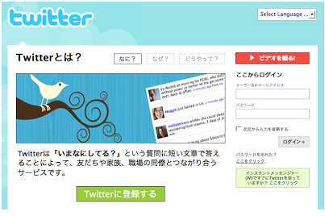Expanding of Twitter throughout the different countries was basically happened in 2008. In order to make more reliable among Japanese, Twitter launched their first non-English version in Japan on April 2008. [44]

Figure 1.3:- Twitter in Japan

And in November of 2008, Twitter could get the attraction for reporting the terrorist attacks in Mumbai. [1] This was played a major role in presidential election of President Barack Obama on November in 2008. [40] That maybe another reason for him to believe Twitter and became the 3rd top most follower of it. [52]

Twitter also encountered some reliability downtimes in the history. For an example on January 5 in 2009, due to a dictionary attack Twitter administrator’s password was guessed correctly and 33 high-profile Twitter accounts were compromised with drug related and sexually explicit tweets. [47] So on June 11 in 2009, Twitter had to launch the beta version of their ‘Verified Accounts’ which was let famous people to announce their Twitter account name. [47]

Even though above mentioned kind of things happened twitter was still reliable among the users during that same year in 2009. A school shooting was taken place on March in Winnenden. But students were tweeted the scene of the killings which indicates how much Germans used it normally and how much they were relying on this social media even at the death bed. [45] And Twitter was the first news supplier in this incident. [53]



Figure 1.4:- 2010–2012